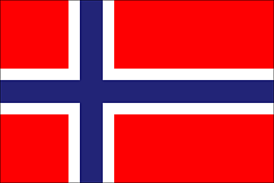The project is funded by Norwegian Government and implemented by UNDP/PAPP

**Progress Report**

**Wadi Gaza Coastal Wetland Conservation and Development**

**15 July 2018**

|  |  |
| --- | --- |
| Reporting Period | 11 December 2017 – 30 June 2018 |
| Donor | Government of Norway |
| Country | occupied Palestinian territory |
| Project Title | Wadi Gaza Coastal Wetland Conservation and Development |
| Atlas Award ID  Project ID  Outputs  (Atlas Project ID and Description) | 00107971  00108030   1. A comprehensive Master Plan for Development, Protection and Conservation of Wadi Gaza. 2. The Institutional Frameworks Options for Realising and Delivering the Global Palestine-Connected Gaza Study; |
| Implementing Partner(s) | United Nations Development Programme / Programme of Assistance to the Palestinian People |
| Project Start Date | 11 December 2017 |
| Project End Date | 31 December 2018 |
| Total Budget | USD 328,129.24 (USD 298,129.24 from NoR and USD 30,000 from UNDP) |
| Revenue received | USD 298,129.24 (NOK 2,500,000) |

|  |  |
| --- | --- |
| UNDP Contact Person | Roberto Valent  UNDP Special Representative of the Administrator  UNDP/PAPP  Email: Roberto.valent@undp.org  Tel: 02-6268150 |

***Table of Content***

I. Executive Summary 3

II. Background 3

III. Progress Review 5

IV. Project Risks and Issues 7

a. Updated project risks and actions 7

b. Updated project issues and actions 9

V. Lessons Learned: 9

VI. Conclusions and Way Forward 9

VII. Financial Status 10

VIII. Annex 11

# Executive Summary

This report summarizes the progress made as of 30 June 2018 in relation to project title’s “Wadi Gaza Coastal Wetland Conservation and Development”. The project aims to contribute to an evidence-based and sustainable rehabilitation and protection of Wadi Gaza natural reserve and coastal wetland which will in turn contribute to considerable health benefits and increased economic opportunities for the surrounding population.

During the reporting period, the project shows advance progress towards the realization of the intended outputs. The project Technical Steering Committee was established and met to discuss the ToR of the committee and the ToR for the consultancy firm that will conduct the master plan. The Request for Proposal was advertised and ten consultancy firms submitted their technical and financial offers. The received offers were evaluated by an evaluation committee which consists of four UNDP staff.

The contract will be awarded to the lowest responsive offer by mid of July 2018. In addition, the development of the Institutional Frameworks Options for Realizing and Delivering the Global Palestine-Connected Gaza has been completed.

Up to date the amount of USD 11,143 Was disbursed which equals 3.7% of the total received amount.

# Background

Wadi Gaza is considered one of the most important coastal wetlands located on the Eastern Mediterranean Basin, very rich in biological diversity (both flora and fauna[1]). Therefore, it is included on the Tentative List[2] of Palestine among the site that can be proposed for inscription on the prestigious World Heritage List as Wadi Gaza Coastal Wetlands (<http://whc.unesco.org/en/tentativelists/5722/> ) within the framework of the World Heritage Convention ratified by Palestine in 2011. Wadi Gaza is considered by the PA as one of the most important coastal wetlands located on the Eastern Mediterranean Basin, very rich in biological diversity (both flora and fauna). The wadi is also a station point for the migratory routes from north to south and from south to north. In addition, being the biggest in Gaza and having an outstanding landscape, and being one of the biggest in Palestine, it has the potential for being a recreational area attracting people from different areas.

In recognition of its importance as a natural area and as the only wetland in Palestine, Wadi Gaza was declared as a nature reserve in June 2006. This decision is meant to conserve the wetland and its ecosystem, to halt and slow degradation of its natural resources and biological systems.

Wadi Gaza Nature Reserve is home to at least 154 terrestrial vertebrate species, most notably birds. It also supports a diverse flora with 70 species. Ongoing loss of habitat is increasing habitat fragmentation and reducing habitat connectivity, because of creeping urban development; alteration and destruction of habitats; environmental pollution; intensive use of herbicides and pesticides; and human disturbance.

Currently, the Wadi is polluted by raw sewage disposed of from towns and camps situated in the middle area of the Gaza Strip (Bureij camp, UNRWA pumping station which suffers from overflow during peak hours, some illegal connections etc.). Where around 2,000 m3 of untreated sewage is discharged directly to the Wadi per day. The temporary wastewater treatment (constructed by ICRC) is overloaded and operates partially due to the electricity cut problem. It is designed with a capacity of 12,000 cubic meter per day while it receives more than 18,000 cubic meters per day. The Wadi is also polluted with illegal dumping of solid waste and construction debris. Such practices threaten the existence of the wetland ecosystem and its biodiversity. As such, it is of critical importance to clean, rehabilitate and protect the Wadi in order to maintain its ecosystem and to restore its importance as natural heritage site and wetland and a global strategic location for soaring birds. It will also serve as a recreational location for the Gaza population with great ecotourism potential and for generating green jobs opportunities.

Wadi Gaza shoulders at the neighbourhood of Al Moghraga - Al Zahra area are relatively low (+5 m above MSL) relative to the surrounding land ( +8 m to +11m above MSL). Accordingly, when the water level in the Wadi rises, it spreads in the area and floods the neighbouring houses and farms and other properties. In January 2010, a large flood occurred in Wadi Gaza and the neighbourhoods of Al Moghraga - Al Zahra area were severely damaged in terms of properties. Hundreds of people were evacuated since their houses and farms were destroyed. The WASH Cluster Assessment shows high concentration rates of chlorides and nitrates and biological contamination in the water supply for Al Nuseirat Camp.

Recently, the borders of the western part of Wadi Gaza which represent about 50% of Wadi length (4.4 Km out of 9 Km) are well known and has formal maps. This area has natural wetland ecosystem, stopover for several birds. The biodiversity knowledge for Wadi Gaza has not been updated since 16 years and there is lack of information related to the Red List of Wadi Gaza flora and fauna and the economic and medical values of the biodiversity in the Wadi. In addition, there is a clear absence of an institutional body or legal framework, which have to be present in the site and have its own rules, laws and staff to make sure that the area is protected against

any illegal environmental offenses or activities. The presence of any institutional body is critical to ensure the sustainability and a successful exit strategy of the project.

This project will deliver two outputs necessary to provide for that rehabilitation and protection of Wadi Gaza:

1. A comprehensive Master Plan for Development, Protection and Conservation of Wadi Gaza.
2. The Institutional Frameworks Options for Realising and Delivering the Global Palestine-Connected Gaza Study.

# Progress Review

**PROGRESS TOWARDS PROJECT OUTPUTS**

|  |  |  |  |
| --- | --- | --- | --- |
| OUTPUT 1: A master plan for Wadi Gaza is developed. | | | |
| **Output Indicators** | Baseline | Target | Current status |
| The printing of the Master Plan itself | Development master plan for Wadi Gaza is not available | The master Development Plan is available | On going |
| During the reporting period, the project shows advance progress towards the realization of the intended outputs:   * The Project Technical Steering Committee (PTSC) was established and composed of the government officials from the Environment Quality Authority (EQA), Ministry of Local Government (MOLG), Palestinian Water Authority (PWA) and the Coastal Municipalities’ Water Utility (CMWU);. in addition to representatives from FAO, UN Environment and UNESCO. NoR participates as an observer. Letters from UNDP were issued to the different ministries to nominate their representatives. TOR for Project Technical Steering Committee (PTSC) was developed and endorsed as per attached ***(Annex #1: ToR for the PTSC)*** * On 27 March 2018, a meeting for the Project Technical Steering Committee was organized. During the meeting, a presentation about Wadi Gaza project was delivered including the overall objective, expected outputs, the available fund, beneficiaries and partners, ToR for the consultancy services for Development of a Comprehensive Master Plan for the Wadi Gaza Area, and the technical steering committee’s composition and roles in this project were discussed. ***(Annex #2: Project Technical Steering Committee Meeting “MoM”)***. * The TOR for the consultancy services was developed and shared with the members of the steering committee for their comments and feedback. * The Request for proposal was prepared and advertised on 30 April 2018 ***(Annex #3: RFP for Development of a Comprehensive Master Plan for Wadi Gaza Area)***, a pre- bid meeting was held on 8 May 2018 and the consultancy offices raised their inquires which were answered by UNDP project manager and disseminated at UNDP website as per attached ***(Annex #4: Addendum #2)***. The initial closing date for the tender was 22 May 2018 but it was extended till 4 June 2018 upon the request of the consultancy offices and due to the political situation in the Gaza Strip during May 2018. * Ten offers were received and opened on 6 June 2018 as per attached ***(******Annex #5: Bid Opening Record)***. * An internal committee from UNDP staff was formed to review and evaluate the received proposals. * The contract will be awarded to the lowest responsive offer (consulting Firm) by mid of July 2018. | | | |
| OUTPUT 2: Institutional Frameworks Options for Realising and Delivering the Global Palestine-Connected Gaza developed | | | |
| **Output Indicators** | **Baseline** | **Target** | **Current Status** |
| The printing and publication of the Study | Draft Study is available | The final Study is available | The study is completed. |
|  | | | |

# Project Risks and Issues

## Updated project risks and actions

The following matrix summarized the updated risks and action taken:

|  |  |  |  |  |  |  |  |  |  |
| --- | --- | --- | --- | --- | --- | --- | --- | --- | --- |
| **#** | **Description** | **Date Identified** | **Type** | **Impact &**  **Probability** | **Countermeasures / Mngt response** | **Owner** | **Submitted, updated by** | **Last Update** | **Action Taken** |
| 1. | Land acquisition by illegal settlers | December 2017 | Operational | Delay in the implementation of the project.  Probability (1-5) = 3  Impact (1-5) = 3 | * Fencing of Wadi Gaza and strengthening of its banks will require that ownership and land acquisitions are addressed and settled from the beginning of the project. * UNDP will coordinate with the Land Authority and with the MOLG to ensure that these issues are addressed and tackled at an early stage during the planning and development stage | UNDP | UNDP | June 2018 | Not faced during the reporting period |
| 2 | Deterioration of security situation in Gaza | December 2017 | External-Political | UNDP and the consultants’ mobility and ability to implement the programme is threatened  Probability (1-5) = 3  Impact (1-5) = 4 | * + - UNDP will coordinate with the Israeli side to provide access to the consultant and the surveyors during the implementation and at the technical level     - Security and contingency planning for UNDP and the consultants     - Two-ways sharing of information on security situation | UNDP | UNDP | June 2018 | Not faced during the reporting period |
| 3 | Lack of qualified consultants in Gaza Strip in specific areas | March 2018 | Operational | Low quality of the final product | * + - UNDP will conduct a quick survey for the available and unavailable required experts. | UNDP | UNDP | June 2018 | According to UNDP quick survey, the unavailable experts in Gaza were identified and requested to be international. |

## 

## Updated project issues and actions

* The project faced a delay due to delay in forming the technical steering committee and delay in nominating the representatives. A request for no cost extension will be submitted to NOR.
* The original planned contribution from NOR equals USD 306,000 while to total amount received is USD 298,124.24. The project team will propose the necessary adjustment and report this to NOR after opening the financial offers.

# Lessons Learned:

- Extend the Steering committee to include representatives from Ministry of Agriculture and the Land Authority.

-The Ministry of Planning, the Ministry of Tourism, the municipalities and the schools which are located near Wadi are stakeholders and should be consulted and involves during the implementation of the project.

- If the political situation improves, the steering committee to be co-chaired with the main government partner (Environment Quality Authority).

# Conclusions and Way Forward

The following activities will be implemented during the coming three months:

1. Sign the contract with the consultancy firm.
2. Finalize the inception phase.
3. Finalize the baseline information reports.
4. Conduct a semi-annual meeting in August 2018 to review the progress of the project, discuss possible revision of the budget and the plan.

# Financial Status

The fund received from NOR is USD 298,129.24 (NOK 2,500,000).



# Annex

Annexes are available on Google Drive:

<https://drive.google.com/drive/folders/17GZcYkHgUPJsYV56RBxk6GEMSzyFXRNN?usp=sharing>

1. Annex #1: ToR for the PTSC
2. Annex #2: Project Technical Steering Committee Meeting “MoM”
3. Annex #3: RFP for Development of a Comprehensive Master Plan for Wadi Gaza Area
4. Annex #4: Addendum #2
5. Annex #5: Bid Opening Record

**Annex 6: Photos**

Project Technical Steering Committee Meeting

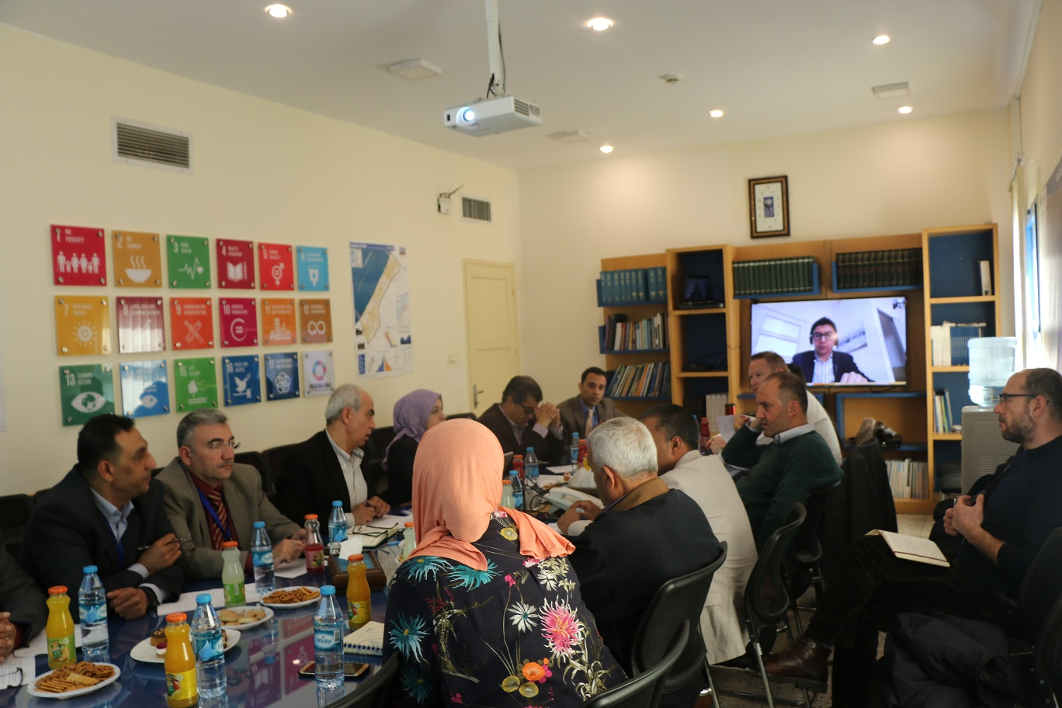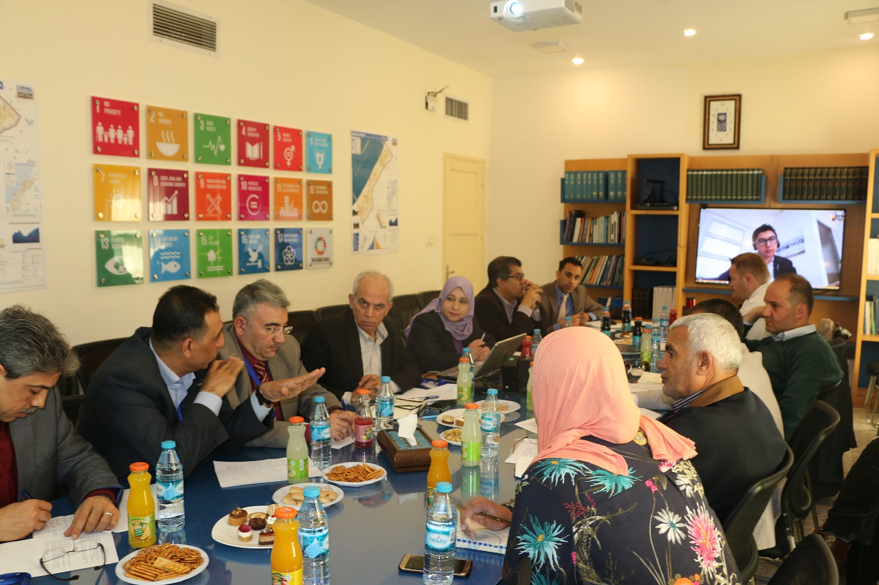

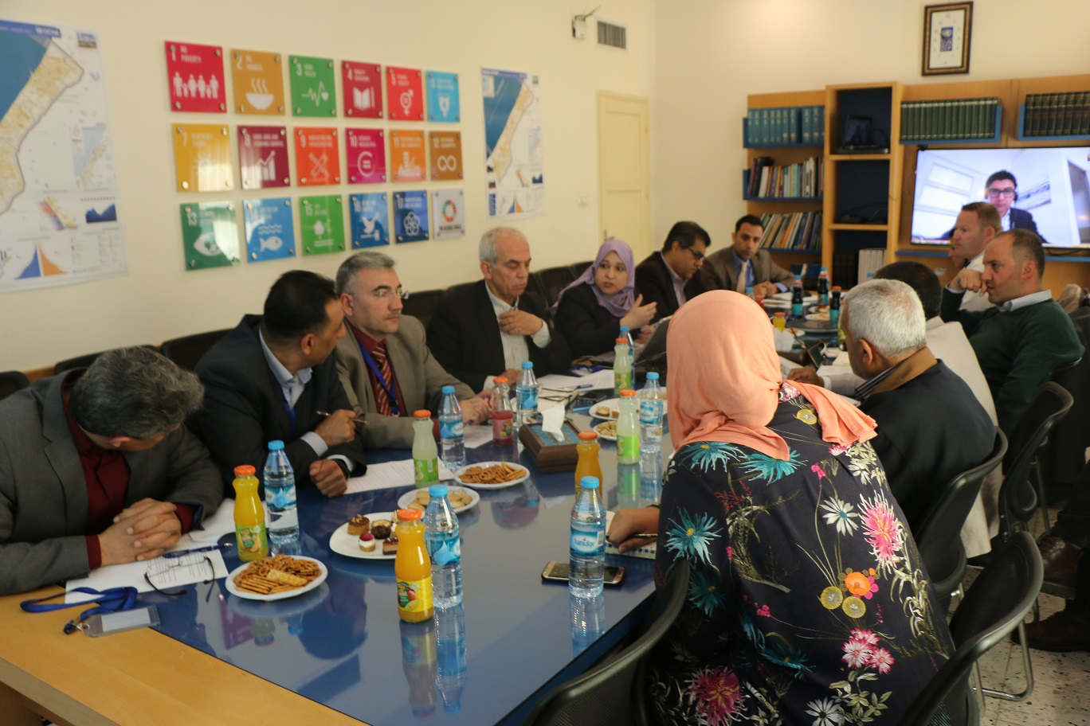

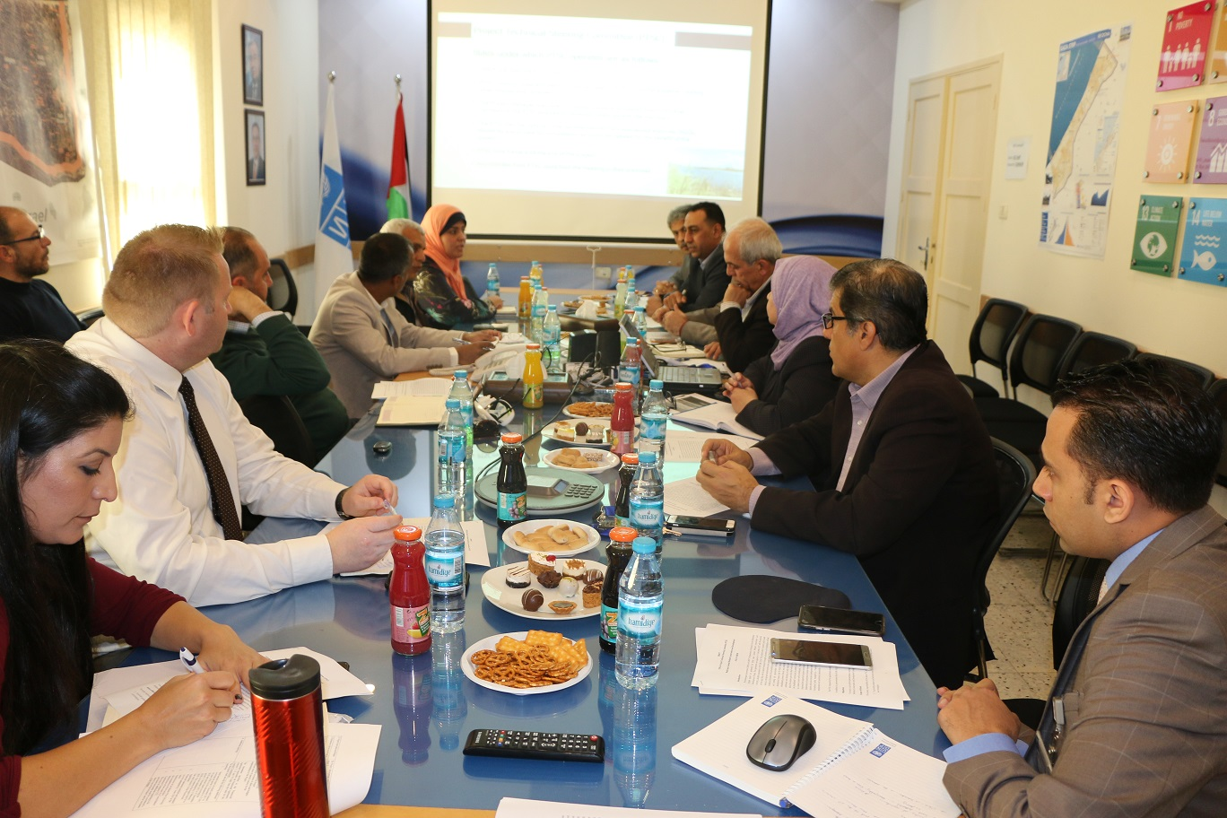

1. Desk Study on the Environment in the Occupied Palestinian Territories, UNEP, 2004;

   Country Report (Wetland Of Wadi Gaza, Palestine), MedPartnership-Strategic Partnership for the Mediterranean Sea Large Marine Ecosystem; UNESCO-IHP Sub component 1.1 Management of Coastal Aquifers and Groundwaters, by Khaled Kahman, 2014.
2.